Facebook and Fake News

Consider each of the below proposals, and fill in each of the below TODOs.

# Proposals

## Proposal 1

Facebook relies on an algorithm as well as individual users’ reports to identify content that is potentially "fake news." Once the content has been identified, it is sent to third party fact-checkers for verification. If the content is verified as fake news, it is publicly flagged with a warning that the content is disputed by fact-checkers.

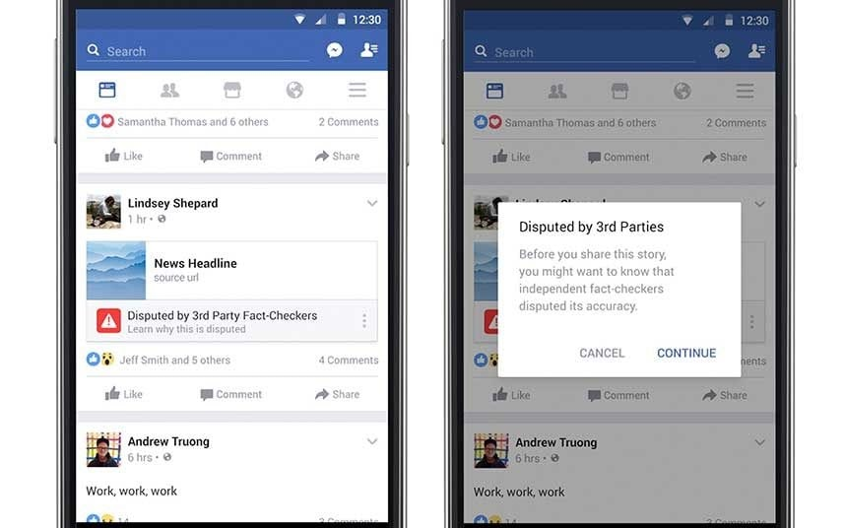

## Proposal 2

However, a designer at Facebook believes that there needs to be a different approach to content regulation. Their proposal is that content deemed problematic by third-party fact-checkers should be prevented from being shared on the platform altogether.

# 

# Questions

1. Which form of content regulation, Proposal 1 or Proposal 2, do you feel is better? Why?
   1. Proposal 2 , because i think can prevent from distribute on the internet and its better than you pay attention to a person for be caferfull
2. Which form of content regulation, Proposal 1 or Proposal 2, do you think best preserves or promotes the [five rights and opportunities necessary for a democratic public sphere](https://cs50.harvard.edu/college/2020/fall/labs/10/lecture/#five-rights-and-opportunities-for-a-democratic-public-sphere)?
   1. Which proposal best preserves or promotes Rights? Why?
      1. Proposal 2 , because can grantee from source of news and you always know this news is right
   2. Which proposal best preserves or promotes Opportunity for Expression? Why?
      1. Proposal 1 , because can give you time for tell about anything and in this situation you can prove to others
   3. Which proposal best preserves or promotes Access? Why?
      1. Proposal 2 , it depends on your news , if you distribute right news you can access to news but if its fake , so your news block
   4. Which proposal best preserves or promotes Diversity? Why?
      1. Proposal 1 , because i think in this form , you can try to make a lot of news by different way and you give feedback and so improve your find way for how to make news
   5. Which proposal best preserves or promotes Communicative Power? Why?
      1. Proposal 1 , extremely , you can connect with any one and publish news and only if 3rd part determine that your news may be fake so , you get a notification and solve your problem .